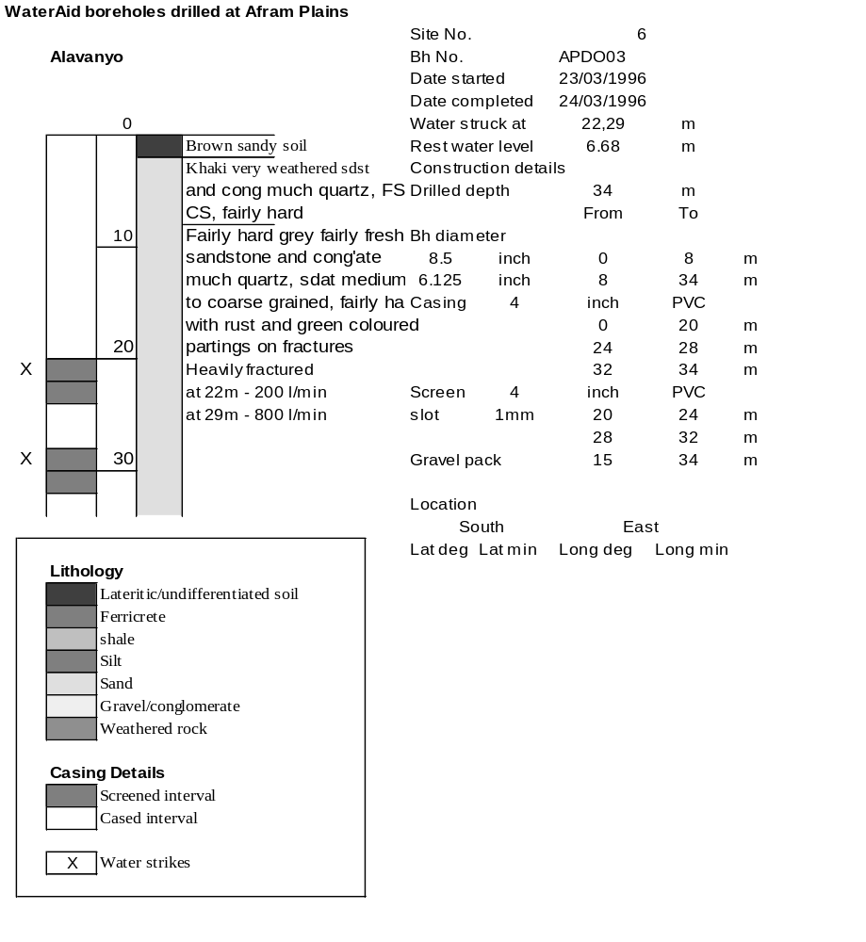

Ghana | Test pumping
Borehole No. |  | APDO3
Hole No |  | 3
Village |  | Alavanyo
Date |  | 15/04/1996
Point above GL |  | 0.5 | m
Pump depth |  | 19 | m
SWL |  | 7.18 | m
Start Time |  | 08:15
Drawdown test |  |  |  |  | Recovery test
time | pwl (m) | Q l/min | dd | sc | Time | wl (m) | s' | t/t'
0.00 | 7.18 | 150.00 | 0.00 |  | 0.00 | 8.52 | 1.34
1.00 | 7.80 | 150.00 | 0.62 | 241.94 | 1.00 | 7.74 | 0.56 | 181.00
2.00 | 7.95 | 150.00 | 0.77 | 194.81 | 2.00 | 7.65 | 0.47 | 91.00
3.00 | 8.05 | 150.00 | 0.87 | 172.41 | 3.00 | 7.60 | 0.42 | 61.00
4.00 | 8.12 | 150.00 | 0.94 | 159.57 | 4.00 | 7.57 | 0.39 | 46.00
5.00 | 8.15 | 150.00 | 0.97 | 154.64 | 5.00 | 7.54 | 0.36 | 37.00
6.00 | 8.18 | 150.00 | 1.00 | 150.00 | 6.00 | 7.53 | 0.35 | 31.00
7.00 | 8.20 | 150.00 | 1.02 | 147.06 | 7.00 | 7.52 | 0.34 | 26.71
8.00 | 8.22 | 150.00 | 1.04 | 144.23 | 8.00 | 7.50 | 0.32 | 23.50
9.00 | 8.24 | 150.00 | 1.06 | 141.51 | 9.00 | 7.49 | 0.31 | 21.00
10.00 | 8.25 | 150.00 | 1.07 | 140.19 | 10.00 | 7.49 | 0.31 | 19.00
11.00 | 8.26 | 150.00 | 1.08 | 138.89 | 12.00 | 7.48 | 0.30 | 16.00
12.00 | 8.26 | 150.00 | 1.08 | 138.89 | 14.00 | 7.47 | 0.29 | 13.86
13.00 | 8.27 | 150.00 | 1.09 | 137.61 | 16.00 | 7.46 | 0.28 | 12.25
14.00 | 8.28 | 150.00 | 1.10 | 136.36 | 18.00 | 7.45 | 0.27 | 11.00
15.00 | 8.29 | 150.00 | 1.11 | 135.14 | 20.00 | 7.44 | 0.26 | 10.00
16.00 | 8.29 | 150.00 | 1.11 | 135.14 | 22.00 | 7.43 | 0.25 | 9.18
17.00 | 8.30 | 150.00 | 1.12 | 133.93 | 24.00 | 7.43 | 0.25 | 8.50
18.00 | 8.30 | 150.00 | 1.12 | 133.93 | 26.00 | 7.43 | 0.25 | 7.92
19.00 | 8.30 | 150.00 | 1.12 | 133.93 | 28.00 | 7.42 | 0.24 | 7.43
20.00 | 8.31 | 150.00 | 1.13 | 132.74 | 30.00 | 7.42 | 0.24 | 7.00
22.00 | 8.33 | 150.00 | 1.15 | 130.43 | 35.00 | 7.41 | 0.23 | 6.14
24.00 | 8.34 | 150.00 | 1.16 | 129.31 | 40.00 | 7.40 | 0.22 | 5.50
26.00 | 8.34 | 150.00 | 1.16 | 129.31 | 45.00 | 7.39 | 0.21 | 5.00
28.00 | 8.35 | 150.00 | 1.17 | 128.21 | 50.00 | 7.39 | 0.21 | 4.60
30.00 | 8.35 | 150.00 | 1.17 | 128.21 | 60.00 | 7.38 | 0.20 | 4.00
35.00 | 8.36 | 150.00 | 1.18 | 127.12 | 70.00 | 7.38 | 0.20 | 3.57
40.00 | 8.36 | 150.00 | 1.18 | 127.12 | 80.00 | 7.38 | 0.20 | 3.25
45.00 | 8.37 | 150.00 | 1.19 | 126.05 | 90.00 | 7.37 | 0.19 | 3.00
50.00 | 8.38 | 150.00 | 1.20 | 125.00 | 100.00 | 7.36 | 0.18 | 2.80
55.00 | 8.39 | 150.00 | 1.21 | 123.97 | 110.00 | 7.36 | 0.18 | 2.64
60.00 | 8.40 | 150.00 | 1.22 | 122.95 | 120.00 | 7.36 | 0.18 | 2.50
70.00 | 8.41 | 150.00 | 1.23 | 121.95
80.00 | 8.43 | 150.00 | 1.25 | 120.00
90.00 | 8.44 | 150.00 | 1.26 | 119.05
100.00 | 8.45 | 150.00 | 1.27 | 118.11
110.00 | 8.46 | 150.00 | 1.28 | 117.19
120.00 | 8.47 | 150.00 | 1.29 | 116.28
130.00 | 8.49 | 150.00 | 1.31 | 114.50
140.00 | 8.49 | 150.00 | 1.31 | 114.50
160.00 | 8.50 | 150.00 | 1.32 | 113.64
180.00 | 8.52 | 150.00 | 1.34 | 111.94
